Oleynik Vladislav

Exercise 11_12

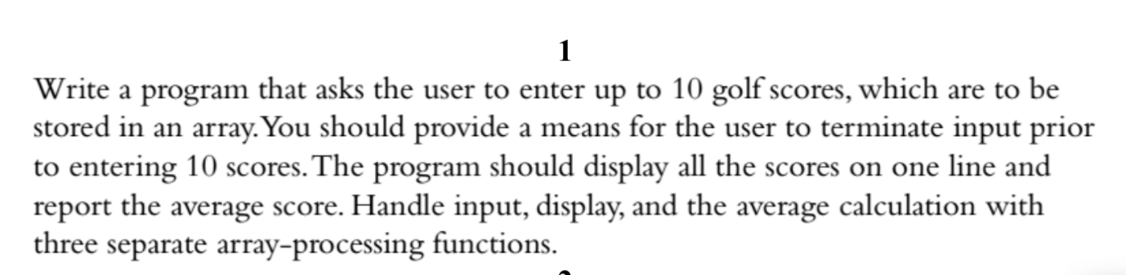

Code:

#include <iostream>

using namespace std;

int scores[10];

int avarage_score = 0;

void input_scores()

{

cout << "Please enter 10 score:" << endl;

for (int i = 0; i < 10; i++)

{

cout << "Enter " << i << " element: ";

cin >> scores[i];

}

cout << endl;

}

void output_scores()

{

cout << "Outputing score data: " << endl;

for (int i = 0; i < 10; i++)

{

cout << scores[i] << " ";

}

cout << endl;

}

void output_avarage_score()

{

int sum = 0;

for (int i = 0; i < 10; i++)

{

sum += scores[i];

}

double average_score = sum / 10;

cout << "Average score is " << average_score << endl;

}

int main()

{

input_scores();

output_scores();

output_avarage_score();

return 0;

}

Output:

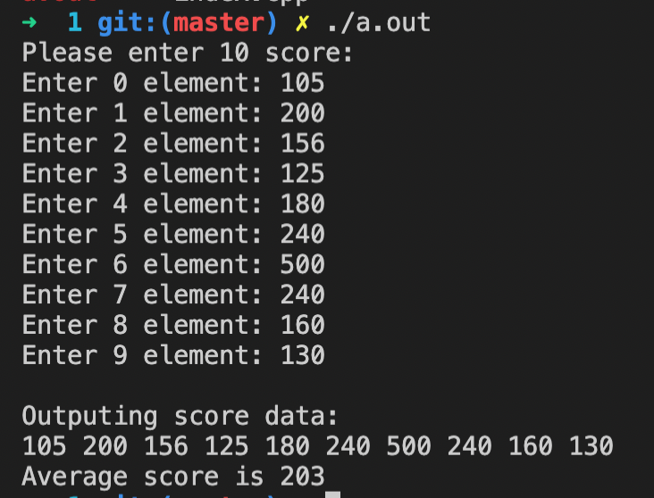

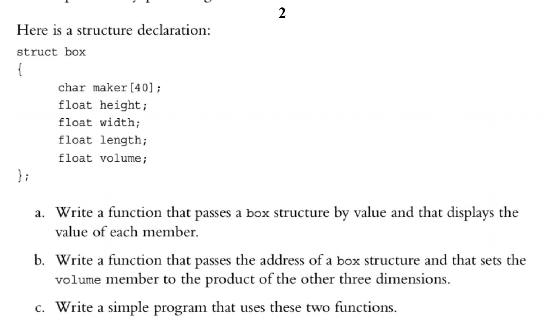

Code:

#include <iostream>

using namespace std;

struct box

{

char maker[40];

float height;

float width;

float length;

float volume;

} box1;

void fillAndOutputBoxData()

{

cout << "=== please fill box data ===" << endl;

cout << "Enter maker: ";

cin >> box1.maker;

cout << "Enter width: ";

cin >> box1.width;

cout << "Enter height: ";

cin >> box1.height;

cout << "Enter length: ";

cin >> box1.length;

cout << "maker: " << box1.maker << endl;

cout << "width: " << box1.width << endl;

cout << "height: " << box1.height << endl;

cout << "length: " << box1.length << endl;

cout << "volume: " << box1.volume << endl;

}

void outputVolume()

{

cout << "=== outputting volume ===" << endl;

int volume = box1.width * box1.height * box1.length;

cout << volume << endl;

}

int main()

{

fillAndOutputBoxData();

outputVolume();

return 0;

}

===OUTPUT===

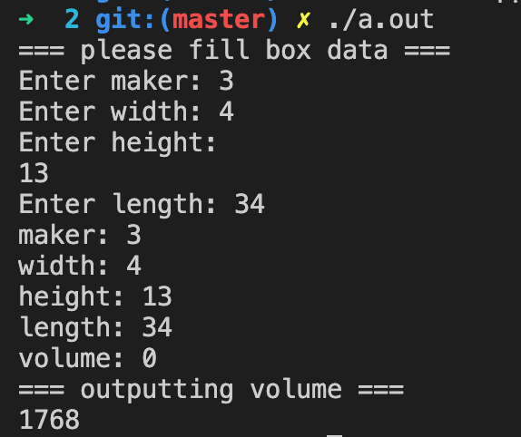}

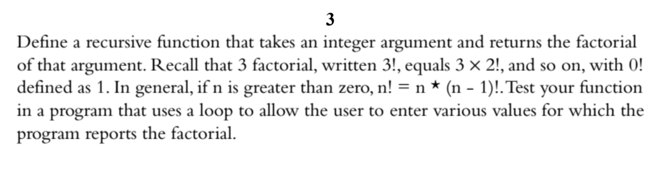

#include <iostream>

using namespace std;

int factorial(int n)

{

if (n > 1)

return n * factorial(n - 1);

else

return 1;

}

int main()

{

int n;

cout << "Enter a positive integer: ";

cin >> n;

cout << "Factorial of " << n << " = " << factorial(n) << endl;

return 0;

}

Output:

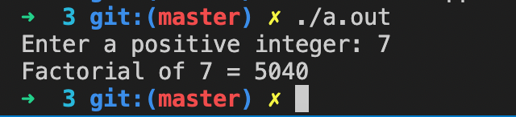

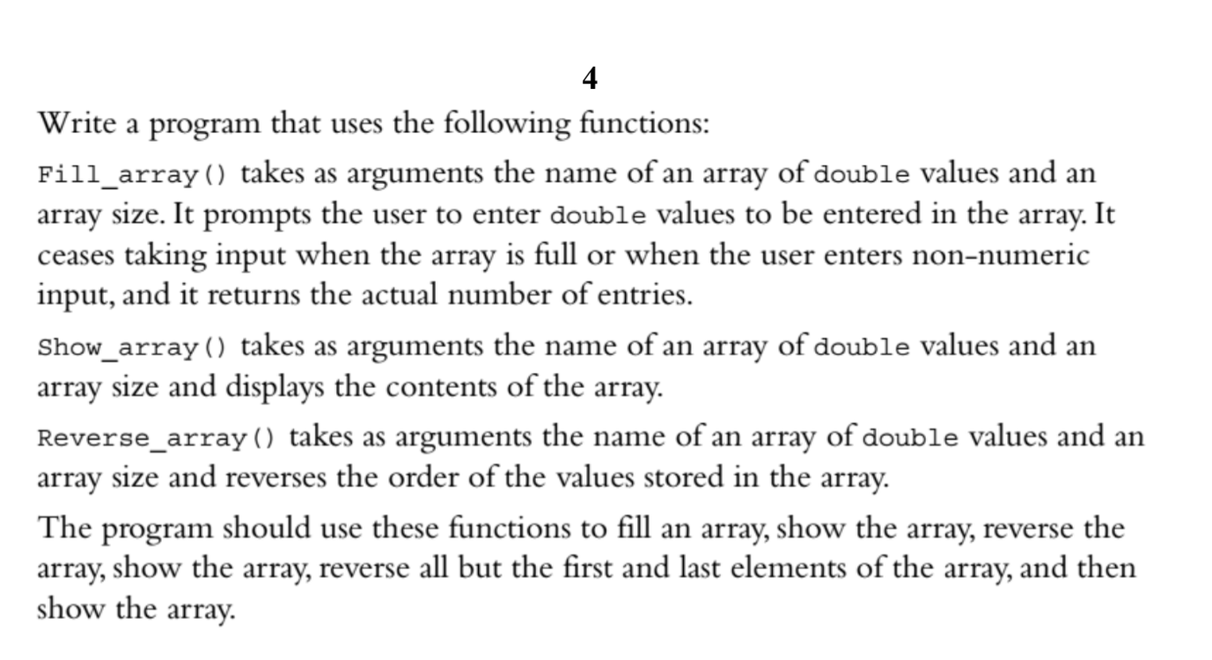

#include <iostream>

using namespace std;

double *array1;

void Fill_array(int size)

{

cout << "=== Please enter elements of array ( type double ) ===" << endl;

array1 = new double[size];

for (int i = 0; i < size; i++)

{

cout << "Enter " << i << " element" << endl;

cin >> array1[i];

}

}

void Show_array(int size)

{

cout << "=== outputting array ===" << endl;

for (int i = 0; i < size; i++)

{

cout << "element " << i << " : " << array1[i] << endl;

}

}

void Reverse_array(int size)

{

cout << "=== reversing array... ===" << endl;

reverse(array1, array1 + size);

cout << "=== array reversed... ===" << endl;

}

int main()

{

Fill_array(5);

Show_array(5);

Reverse_array(5);

Show_array(5);

return 0;

}

Output:

